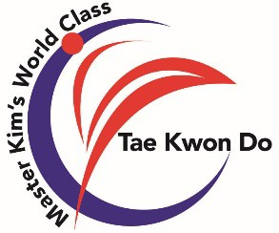July/August 2022 Monthly Class Management

Keep your Promise and your Promise will Protect you

|  |  |  |  |  |  |
| --- | --- | --- | --- | --- | --- |
| Week # | Date | Monday/Tuesday | Thursday/Friday | Curriculum | Special Events |
| 1 | June 27th To  July 2nd | PD-Basic  Warm-up 1 | PD-Combination  Warm-up 1 | P |  |
| 2 | July 4th – 9th | Closed | Closed |  | 4th-9th Closed  9th- O-22 4-hr class |
| 3 | July 11th -16th | DST- Basics  Warm-up 2 | DST- 1,2,3,4  Warm-up 2 | P | 11th -14th Summer Camp #2 9am-12noon |
| 4 | July 18th – 23rd | PD-Counterattack  Warm-up 1 | PD-Sparring  Warm-up 1 | O/SD | 23rd- Team O-22 Breaking M. Test @ 9:50am |
| 5 | July 25th – 30th | Testing Preparation  Warm-up 4 | Testing Preparation  Testing | T | 29th – Belt Testing |
|  |  |  |  |  |  |
| 6 | August 1st -6th | PD-Basic  Warm-up 1 | PD-Combination  Warm-up 1 | P | 1st -4th Summer Camp #3 9am-12noon  6th Team O-22 Final 4- Hr Class |
| 7 | August 8th -13th | DST- Speed  Warm-up 2 | Big Shield  Warm-up 2 | P | 8th -11th Summer Camp #4 9am-12noon |
| 8 | August 15th – 20th | PD-Counterattack  Warm-up 1 | PD-Sparring  Warm-up 1 | OSS/SD | 15th School begins in Greenville, SC |
| 9 | August 22nd -27th | Testing Preparation  Warm-up 4 | Testing  Special Classes Warm-up 1 | T | 25th August Belt Testing  27th Master Hwang BB Test |
|  |  |  |  |  |  |

*July 4th-Juky 8th Closed- Independence Day/Summer Break

*July 29th- Belt Testing

*August 15th- School begins in Greenville, SC

*August 25th- Belt Testing